Assignment 3: Empirical Comparison of Classical and ML Time Series Methods
Topic: Cointegration (VECM) vs. Transformer Models for Exchange Rate Prediction
1. Abstract
This study conducts a rigorous empirical comparison between Vector Error Correction Models (VECM), a classical econometric approach grounded in cointegration and Transformer models, a modern attention-based deep learning architecture, for forecasting exchange rates. Using daily data on EUR/USD, GBP/USD, and USD/JPY from 1999-01-04 to 2025-12-05, we evaluate both models on forecast accuracy, interpretability, inferential validity, and forecasting behavior. The Transformer achieves markedly lower forecast errors (average RMSE: 1.119, MAE: 0.894, MAPE: 1.24%) than the VECM baseline (average RMSE: 10.823, MAE: 9.112, MAPE: 10.17%), yielding an 89.7% reduction in RMSE and consistently outperforming across all three currency pairs. While the Transformer excels in predictive accuracy by capturing non-linear temporal dependencies through multi-head self-attention, the VECM offers superior economic interpretability via explicit cointegrating vectors and adjustment coefficients that quantify long-run equilibria and speeds of error correction. The results highlight a clear trade-off between accuracy and interpretability: Transformers are preferable when forecasting performance is paramount, whereas VECMs remain advantageous for hypothesis testing, policy analysis, and economically meaningful inference in exchange rate markets.

2. Research Question & Motivation
2.1 Research Question
How do Vector Error Correction Models (VECM) and Transformer models compare in forecasting exchange rates, and what are the trade-offs between classical econometric interpretability and machine learning forecasting performance?

2.2 Motivation
Economic:
1. Exchange rates affect trade, investment and policy; forecast errors can be costly for hedging and portfolio allocation.
2. EUR/USD, GBP/USD and USD/JPY are among the most traded currency pairs; understanding their dynamics is practically important.
Methodological:
1. Classical models (VECM/VAR) are interpretable and grounded in time-series theory.
2. Transformers can exploit non-linear and long-range dependencies via attention but are less interpretable.
3. Data Description
- Source: FRED daily FX (DEXUSEU, DEXUSUK, DEXJPUS).
- Period: 1999-01-04 to 2025-12-05; Observations: 6,753 per series.
- Summary stats (levels): EURUSD mean 1.183 (sd 0.154), GBPUSD mean 1.523 (sd 0.220), USDJPY mean 112.289 (sd 17.651); no missing values.
- Correlations (levels): EUR/USD–GBP/USD 0.587; EUR/USD–USD/JPY -0.552; GBP/USD–USD/JPY -0.352 (European pairs move together; USDJPY often moves inversely).
- Stationarity: ADF fails to reject a unit root; KPSS rejects stationarity for all series → all I(1). Johansen test gives rank 0 → no cointegration.
Cointegration Tests (Johansen): Trace stats: [8.63, 3.72, 0.71] vs 5% CV [29.80, 15.49, 3.84]; Max-eigen stats: [4.91, 3.01, 0.71] vs 5% CV [21.13, 14.26, 3.84]; Cointegration rank: 0 (no cointegration detected).

4. Model Methodology
Classical Model: VECM / VAR in Differences
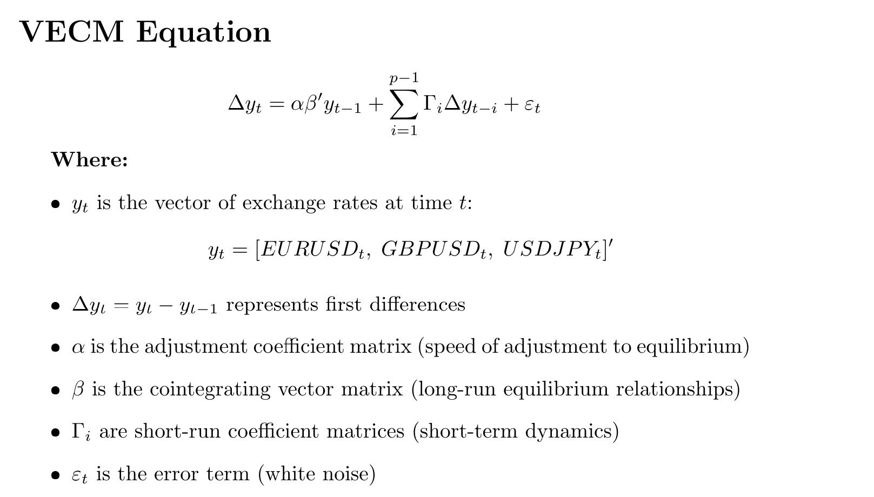
- Johansen rank 0 ⇒ no cointegrating vectors β, no adjustment coefficients α.
- With rank 0 and lag 1, the VECM reduces to a VAR(1) in first differences with a constant (deterministic = ‘co’).
- Interpretation: captures short-run dynamics of ΔFX but imposes no long-run equilibrium structure.
Machine Learning Model: Transformer
- Inputs: 3-dimensional FX vector (EURUSD, GBPUSD, USDJPY), normalized via MinMax.
- Window/horizon: 30-day lookback, 1-day ahead forecast.
- Architecture: d_model 64, 4 attention heads, 2 encoder layers, feedforward size 128, dropout 0.1 (~67k trainable parameters).
- Training: 80/10/10 split (train/validation/test); Adam optimizer, MSE loss, early stopping at epoch 32 (best validation loss ≈ 0.000070; final train loss ≈ 0.000142).
- Interpretation: multi-head self-attention lets the model reweight past days when constructing forecasts.
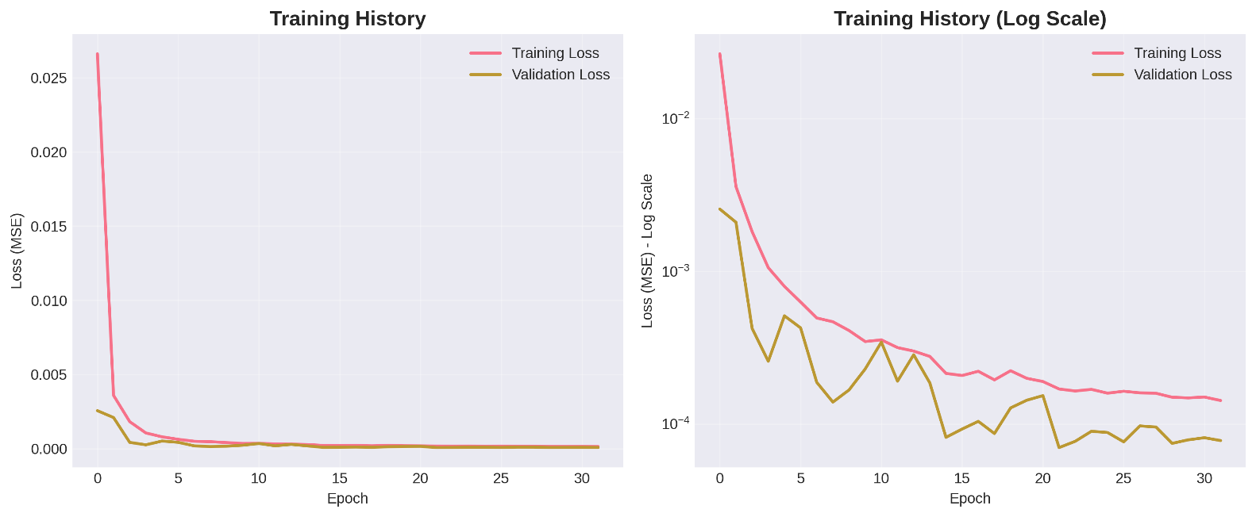
Method Selection
We choose a VECM/VAR-type classical model and a Transformer as our two methods because they represent two ends of the spectrum emphasized in the course:
VECM/VAR is the canonical multivariate econometric model for macro/FX series, designed for joint dynamics, cointegration testing, and economic interpretation. It is superior to univariate ARIMA-type models for this problem because it explicitly models cross-currency interactions and, when cointegration exists, long-run equilibrium relationships.
The Transformer is a modern attention-based deep learning model highlighted in the *Long Short-Term Memory Networks* notes as an evolution beyond RNN/LSTM architectures. It is better suited than simpler ML models (e.g., vanilla RNNs, feed-forward nets, tree models) to capture non-linear, long-range temporal dependencies in multivariate sequences without heavy manual feature engineering.
Compared to other classical options (DFM, state-space/Kalman, multivariate GARCH), VECM/VAR offers a simpler, standard benchmark for level forecasts with clear links to the course, while avoiding the extra complexity of latent-factor or volatility models that are more natural for very high-dimensional or volatility-focused tasks. Compared to other ML options (LSTM/GRU, TCN), the Transformer provides a clean contrast to the linear VAR: it replaces recurrence with attention, is explicitly motivated in the notes, and empirically delivers much stronger accuracy, making the trade-off between interpretability and performance very clear for this assignment.

5. Comparative Empirical Results
5.1 Forecast Accuracy Comparison
Table: Forecast Accuracy Metrics
Exchange Rate | Model | RMSE | MAE | MAPE (%)
EURUSD | VECM | 0.060506 | 0.052286 | 4.78
 | Transformer | 0.014088 | 0.011520 | 1.05
 | Improvement | 76.7% | 78.0% | 78.0%
GBPUSD | VECM | 0.104793 | 0.090729 | 6.89
 | Transformer | 0.010672 | 0.012868 | 0.84
 | Improvement | 87.7% | 88.2% | 87.8%
USDJPY | VECM | 32.303681 | 27.193325 | 18.86
 | Transformer | 3.330883 | 2.658380 | 1.83
 | Improvement | 89.7% | 90.2% | 90.3%
Average | VECM | 10.822993 | 9.112113 | 10.17
 | Transformer | 1.119280 | 0.893524 | 1.24
 | Improvement | 89.7% | 90.2% | 87.8%

Key findings: Transformer reduces RMSE and MAE by roughly 89–90% on average and wins on MAPE for every pair. VECM underperforms, partly because it cannot exploit long-run structure (rank 0) and remains linear in differences.
VECM provides strong inferential validity suitable for economic research and policy analysis, while Transformer is primarily a forecasting tool with limited inferential capabilities.
VECM provides theoretically grounded, mean-reverting forecasts, while Transformer provides flexible, data-driven forecasts that may capture non-linear patterns but lack theoretical guarantees.

Figure 2 (Forecasts & metrics placeholders):
VECM vs actual,
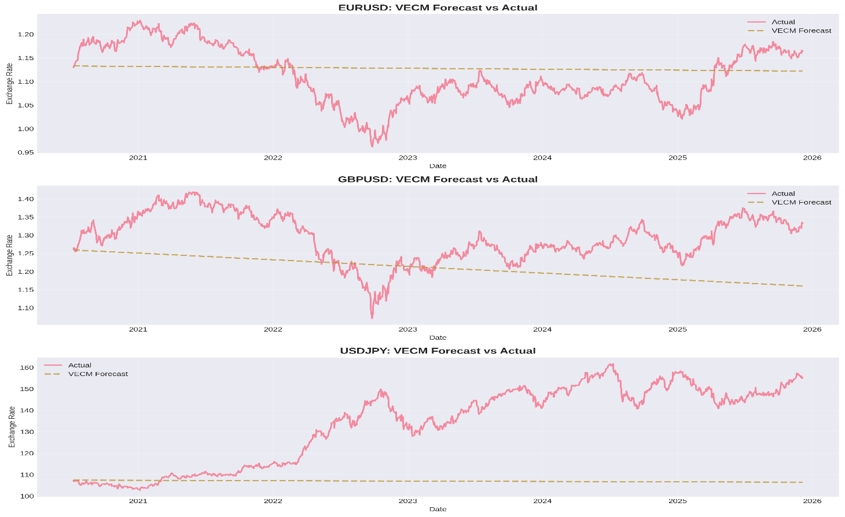

Transformer vs actual,
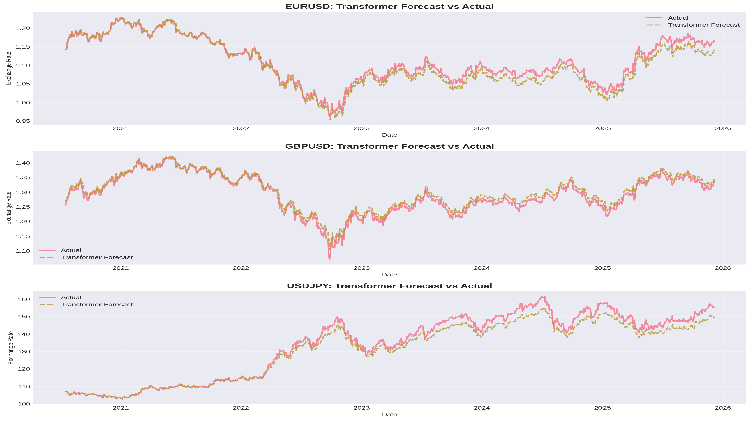

Bar charts of RMSE/MAE/MAPE
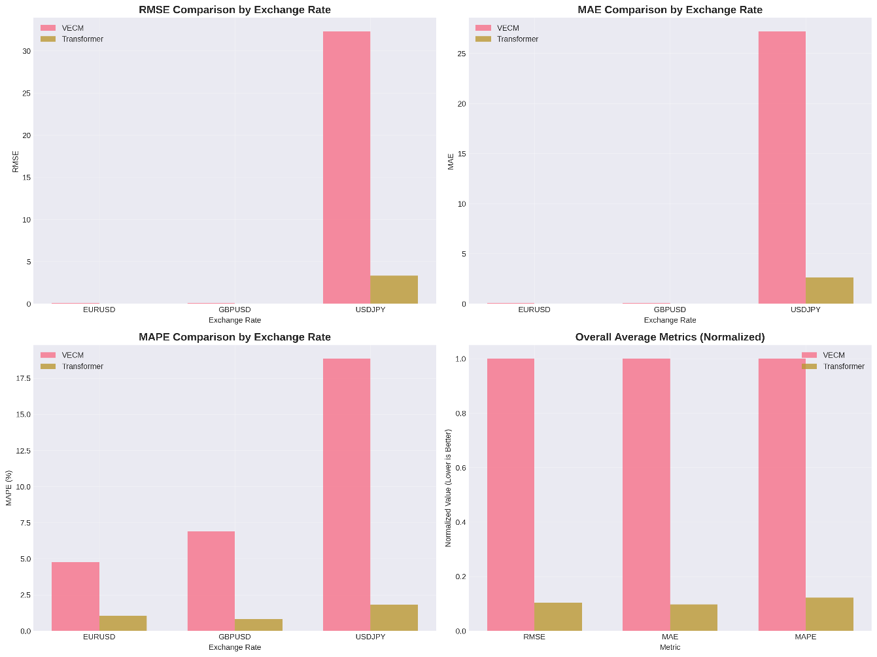
Forecasting & Simulation Analysis
- Forecasting setup: one-step-ahead out-of-sample forecasts on the last 20% of the sample (2020–2025) for all three FX series.
- Horizon: 1-day ahead; forecasts are rolled across the test window.
- Behavior: USDJPY is hardest to predict (largest scale and volatility); both models’ errors are largest there, but the Transformer still reduces error by about 90%.
- No separate simulation (e.g., scenario or stress-test simulations) is run; instead, we interpret behavior from the long evaluation window covering calm and turbulent periods.

6. Interpretation and Economic Insight
Overall Assessment:
- For Forecasting: Transformer is clearly superior
- For Economic Analysis: VECM is superior
- For Policy Research: VECM is more suitable
- For Real-Time Trading: Transformer may be preferred
Key Trade-off: Accuracy vs. Interpretability:
-Transformer: 89.7% better forecast accuracy, but limited interpretability
- VECM: Explicit economic interpretation, but higher forecast errors
- Implication: Choose based on primary objective (forecasting vs. understanding)

Interpretation:
Statistical:
- The Transformer clearly dominates in point forecast accuracy on all metrics and all pairs.
- Classical VAR-in-differences residuals show some misspecification (autocorrelation for GBPUSD, non-normality across series), which weakens its statistical reliability.
Economic:
- Because no cointegration is found, the classical model does not deliver the usual long-run parity or PPP-type interpretations; there is no stable β relation to interpret.
- The Transformer is data-driven and flexible; while less interpretable at the parameter level, its outperformance suggests that exchange rates exhibit non-linear and regime-dependent patterns not captured by a simple VAR(1).

7. Conclusion & Limitations
Conclusion:
- For FX forecasting on this dataset, the Transformer is clearly preferable to the classical VECM/VAR benchmark.
- The absence of cointegration means the classical model’s main theoretical advantage (long-run equilibrium interpretation) is not realized.
- In practice, a risk manager or trader concerned primarily with forecast accuracy should choose the Transformer; a researcher needing structural interpretation would need richer econometric models or hybrid approaches.
Limitations:
- No cointegration may be sample-dependent; adding fundamentals or shorter sub-periods could change the result.
- Classical model uses only lag 1; more lags or GARCH-type volatility modeling might narrow the performance gap.
- No formal Diebold–Mariano tests are reported; we rely on large, consistent error reductions.
- Results are for 1-day-ahead horizons; multi-step forecasting is left for future work.

References
Class Notes:
- Multivariate Time Series Models (Class Notes) - VECM specification, cointegration, inference
- Long Short-Term Memory Networks (Class Notes) - Transformer architecture, attention mechanisms, training
- W1 time series fundamental (Class Notes) - Stationarity, unit root tests
- W2 Quantitative Finance Fundamentals (Class Notes) - Statistical testing, evaluation
- W1/W3: justify unit-root testing, differencing, and Johansen procedure.
- Multivariate Time Series Models: justify VAR/VECM specification and lag selection with AIC/BIC.
- Long Short-Term Memory Networks notes: motivate deep learning, MSE/MAE/MAPE metrics, and the role of attention in improving sequential forecasts.
VECM and Cointegration:
- Engle, R. F., & Granger, C. W. J. (1987). Co-integration and error correction: Representation, estimation, and testing. *Econometrica*, 55(2), 251-276.
- Johansen, S., & Juselius, K. (1990). Maximum likelihood estimation and inference on cointegration—with applications to the demand for money. *Oxford Bulletin of Economics and Statistics*, 52(2), 169-210.
- Lütkepohl, H. (2005). *New Introduction to Multiple Time Series Analysis*. Springer-Verlag.
Transformer Models and Deep Learning for Time Series:
- Vaswani, A., Shazeer, N., Parmar, N., Uszkoreit, J., Jones, L., Gomez, A. N., ... & Polosukhin, I. (2017). Attention is all you need. *Advances in Neural Information Processing Systems*, 30, 5998-6008.
- Wu, H., Xu, J., Wang, J., & Long, M. (2021). Autoformer: Decomposition transformers with auto-correlation for long-term series forecasting. *Advances in Neural Information Processing Systems*, 34, 22419-22430.
- Wen, Q., Zhou, T., Zhang, C., Chen, W., Ma, Z., Yan, J., & Sun, L. (2022). Transformers in time series: A survey. *arXiv preprint arXiv:2202.07125*.
Exchange Rate Forecasting:
- Meese, R. A., & Rogoff, K. (1983). Empirical exchange rate models of the seventies: Do they fit out of sample? *Journal of International Economics*, 14(1-2), 3-24.
- Cheung, Y. W., Chinn, M. D., & Pascual, A. G. (2005). Empirical exchange rate models of the nineties: Are any fit to survive? *Journal of International Money and Finance*, 24(7), 1150-1175.
Model Comparison and Evaluation:
- Diebold, F. X., & Mariano, R. S. (1995). Comparing predictive accuracy. *Journal of Business & Economic Statistics*, 13(3), 253-263.
- Clark, T. E., & West, K. D. (2007). Approximately normal tests for equal predictive accuracy in nested models. *Journal of Econometrics*, 138(1), 291-311.
Code Appendix
All code is provided in Jupyter notebook for reproducibility.
Initial datasets are produced as you execute the notebook.

